COMP3910 Assignment Two

Due Date: Wednesday, November 13th, 2013 @ 10:30 pm

ASSIGNMENT GOALS AND OBJECTIVES

This assignment allows you to refine and demonstrate skills such as:

- Continuation of the concepts learned in assignment one.
- Further JSF techniques for the view layer.
- Using JDBC (or JPA – requires much more self-learning) in a web application context

WORK TEAMS

This assignment may be done in teams of up to two people. This does not preclude the assignment being done individually. Team members must be from the same option set.

REFERENCE

The following sources may be useful when you are working on this assignment:

- 3910 lab assignments and solutions.
- Java reference material from outline and examples.
- Online help for the various tools you may use.

ASSIGNMENT DESCRIPTION

For this assignment implement the following:
The functionality is the same as in assignment 1. The technology is as follows:
- The user interface must be a web interface, using server-side scripting to implement (JSF for control, Facelets for view).
- There must be CDI Beans backing the user interface forms
- A database (MySQL) must be used to persist the data (user information and timesheet data).
- All data stored in the database must be able to be created, retrieved, updated and deleted via the user interface.
- The application should run on JBoss EAP 6.1 and use a data source to connect to the database. It should be possible to have the database on a separate host from the application server.
- All messages, labels, etc must come from a messages resource bundle, as in the text JSF examples.
- All inputs must be validated, displaying error messages if they are not in the proper format, range.
The system is a distributed (or at least distributable) application with a GUI front end that uses components which may eventually reside on the same or different machines. The components encapsulate the functionality required to process the requests from the User Interface.
The web front end connects to a Business Layer. The middleware business components encapsulate the functionality required to process the requests from the User Interface. In turn, the components will access a database via JDBC (or JPA) to store their persistent data.
The general architecture is shown in the following block diagram, with each box capable of running on a different host.

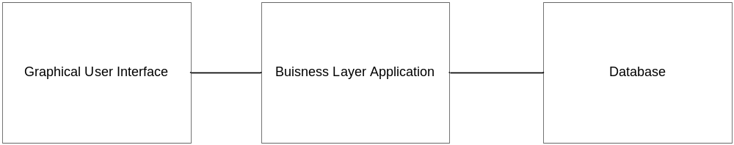

The system is a timesheet entry system. A user can
- Create/Read/Update/Delete users (probably only one superuser should be able to do this – you can define how this works)
- login to the system with a username/password. A user will also have an employee number (E Number) which is numeric.
- create/fill in a timesheet of activities performed in the current week
- view a timesheet previously entered
- edit a timesheet for the current week
Sample timesheet:
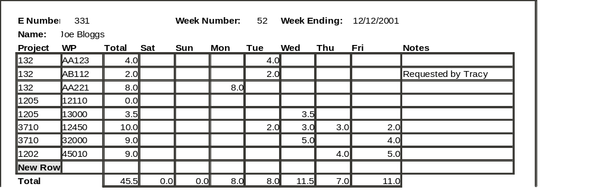
All of the fields in the time sheet have to be entered through the application and stored in a database.
A new timesheet should have 5 empty rows for entry of project/work-package times. There must be a mechanism (such as clicking on a new-row button) for adding additional rows.
The project field is numerical; the WP field is a string. The combination of project and WP must be unique within a timesheet.
Times entered in the week-day columns are in units of hours. Valid values are in the range [0.0 .. 24.0] and may be integers or decimal with one fractional digit (use bean validation to ensure this. As floating point has round off errors, consider using java.math.BigDecimal for the cell type).
The header fields are filled in by the system automatically. The week number and week-ending fields default to the current week.
The Total column and row are calculated based on the data in the week-day columns.

The design should separate the database access from the database entity classes (the classes that hold the persisted data in Java), similarly to the web-database example in lecture.
For the design, provide an entity relationship diagram for the database, and specify the definition of the calling sequences of the components (interface or class definitions, as appropriate). A key part of the design of any system is the interfaces between components. You can focus on the services that the GUI needs to satisfy the user requests. Also provide screen designs for the user interface. A UML class diagram with the interfaces between each of the layers should be part of the design.
Since the components might be running outside of the process space of the user interface, and might be (in an operational system) running on a separate computer, you should design the components to minimize the number of calls from the user interface client to objects created from the back end.
Try to pass any data in bulk with as few calls as possible. In general, the interface that the user interface sees to the data need not be the same as the database; it is better if the components hide the data structure and provides the services the application requires to access and modify the data. A typical design choice is to define a class (called a value object class or Data Transfer Object) to represent the data that is transferred. This class has only getter and setter methods to extract the encapsulated data. In Java, it has to implement java.io.Serializable so it can be sent over the network.
After making these choices you should have three layers:
- Presentation tier (JSF, CDI Beans that prepare data for the presentation layer)
- Business objects tier (CDI Beans, that implement CRUD operations on the database, data beans)
- Persistence tier (the database itself - provided by mysql)
Your solution has to be user friendly and convenient for the user to carry out typical tasks.
DELIVERABLES

You must submit the following for grading:
- An assignment report containing:
  - A more detailed statement of requirements that your solution will satisfy.
  - A test plan for your solution, indicating reasonable test cases that will adequately test your solution.
  - A detailed design of your solution, outlining design decisions, strategy, program organization, menu structure, etc.
  - Printed images (screen snapshots) of all your forms.
  - Test results indicating thorough testing.
  - Instructions for building and running your project (include the information required to set up the data source for the database connection).
- A zipped file in the sharein containing all the files that make up your project. The file name should be in the format name1-name2.zip with both names of the partners, and should be submitted into a folder under /in/comp/3910/assignments/assignment2/. The file should be a maven project or an eclipse project. In either case, it should be possible to import it in to eclipse, where it can be built and run.
- Ensure that your code follows all rules of style as per the Sun Web site: http://java.sun.com/docs/codeconv/html/CodeConvTOC.doc.html If you do not understand any of the code conventions, please see your instructor.
- Ensure that your javadoc documentation follows the rules found in this document

ASSIGNMENT SUBMISSION GUIDELINES

- Email submissions will NOT be accepted.
- Assignments are due before as stated on the first page.
- Late assignments will be accepted (subject to penalties outlined in the grading section of this assignment).

GRADING

Assignments will be graded out of 30, with marks assigned for:

- Overall solution requirements and design (do the requirements make sense, is the design correct and reasonable, is it documented, is it implemented as documented, are design decisions/assumptions documented)
- Code quality (is the code commented correctly and adequately, and coding standards followed, is the code robust and maintainable)
- Program correctness (does the program work, does it work as expected, does it work as designed, does it meet or exceed the requirements outline in the assignment description)

Some additional grading policies

- Assignments with undocumented or unstructured code will receive a grade of no greater then 50%.
- Assignments that do not work at all (can not be run at BCIT) will receive a grade of no greater then 50%.
- Assignments that are copied will result in a grade of 0 (zero) for each party involved, as well as disciplinary action as outline in the BCIT guidelines.
- Assignments submitted with a virus will receive a grade of 0 (zero).
- These grading policies are subject to change at the discretion of the instructor.

LATE ASSIGNMENTS

- Late assignments will be assessed a penalty of 10% (3/30) per day. Weekends count as one day. Assignments are counted as received when the lab instructor gets it, so it would be a good idea to send your lab instructor an email to ensure he checks his box that day.
- Assignments that are more than 10 days late will receive 0 (zero) marks.

BONUS MARKS

There are many ways to receive bonus marks on your assignment:

- Complete the requirements/design work ahead of time
  - If you submit a complete requirements statement and design for your solution on or before November 6th, and your final submission substantially implements your design as submitted, you will receive a bonus of 10% (3/30).
- Include additional functionality
  - Assignments which implement a complete solution to the problem and include significant additional functionality may be assigned bonus marks (up to 20% (6/30). To help your chances, document what you think is the additional functionality.
- Creative and productive use of custom JSF tag files that you write
  - bonus marks up to 10% (3/30).
- Deliver your project so it can be built with maven
  - bonus marks up to 10% (3/30).
- Be able to display the user interface in a second language.
  - bonus marks up to 10% (3/30).

